Test Bank—Chapter Six (Programming Languages)

Multiple Choice Questions

1. Which of the following is an example of a language that is based on the functional paradigm?

A. LISP B. PROLOG C. C D. C++

ANSWER: A

2. Which of the following is an example of a language that is based on the object-oriented paradigm?

A. LISP B. PROLOG C. C D. C++

ANSWER: D

3. Most machine languages are based on the

A. Imperative paradigm B. Declarative paradigm
C. Functional paradigm D. Object-oriented paradigm

ANSWER: A

4. Which of the following is not a type of statement found in a typical high-level imperative programming language?

A. Imperative statement B. Exclamatory statement
C. Declarative statement D. Comment statement

ANSWER: B

5. Which of the following does not require a Boolean structure?

A. If-then-else statement B. While loop statement
C. Assignment statement D. For loop statement

ANSWER: C

6. Which of the following is not a control statement?

A. If-then-else statement B. While loop statement
C. Assignment statement D. For loop statement

ANSWER: C

7. Which of the following is not a control statement?

A. If-then-else statement B. While loop statement
C. Assignment statement D. For loop statement

ANSWER: C

8. Which of the following is not a step in the process of translating a program?

A. Executing the program B. Parsing the program
C. Lexical analysis D. Code generation

ANSWER: A

9. Which of the following is not associated with object-oriented programming?

A. Inheritance B. Resolution C. Encapsulation D. Polymorphism

ANSWER: B

10. Which of the following is not associated with the concept of data type?

A. Coercion B. Boolean C. Operator precedence D. Strongly typed language

ANSWER: C

11. Positions within arrays are identified by means of numbers called

A. Indices B. Parameters C. Instance variables D. Constants

ANSWER: A

12. Which of the following is ignored by a compiler?

A. Control statements B. Declarations of constants
C. Procedure headers D. Comment statements

ANSWER: D

13. Which of the following is not a possible value of the expression 4 + 6 ÷ 2 - 1

A. 4 B. 5 C. 6 D. 10

ANSWER: B

14. Which of the following is not a way of referring to a value in a program?

A. Variable B. Literal C. Constant D. Type

ANSWER: D

15. Which of the following is the scope of a variable?

A. The number of characters in the variable’s name
B. The portion of the program in which the variable can be accessed
C. The type associated with the variable
D. The structure associated with the variable

ANSWER: B

16. Which of the following is a means of nullifying conflicts among data types?

A. Inheritance B. Parsing C. Coercion D. Code optimization

ANSWER: C

17. Which of the following is not constructed by a typical compiler?

A. Source code B. Symbol table C. Parse tree D. Object program

ANSWER: A

18. Which of the following is a means of defining similar yet different classes in an object-oriented program?

A. Inheritance B. Parsing C. Coercion D. Code optimization

ANSWER: A

19. Which of the following is not a parse tree of an expression based on the following grammar?

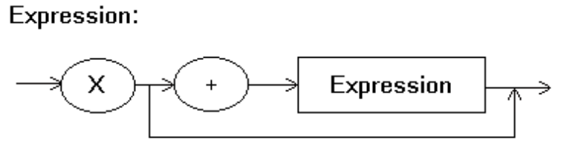

A. B. C.
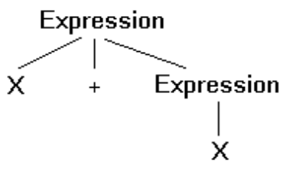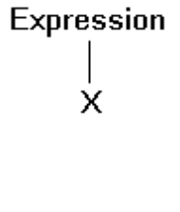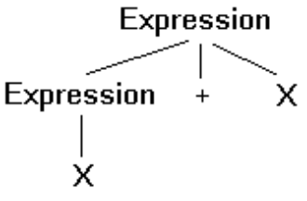

ANSWER: C

20. Which of the following statements is not a resolvent of the following clauses?

P OR Q OR ¬R ¬P OR T ¬Q OR T R OR T

A. Q OR ¬R OR T B. T OR P C. P OR ¬R OR T D. Q OR T

ANSWER: B

21. Which of the following can Prolog conclude from the following program?

parent(jill, sue).
parent(jill, sally).
parent(john, sue).
parent(john, sally).
sibling(X, Y) :- parent(Z, X), parent(Z, Y).

A. parent(jill, john) B. sister(sue, sally)
C. sibling(sue, sally) D. sibling(jill, sue)

ANSWER: C

Fill-in-the-blank/Short-answer Questions

1. In contrast to _______________ languages such as English and Spanish, programming languages are

considered _______________ languages and are rigorously defined by their grammars.

ANSWER: natural, formal

2. List two disadvantages of both machine languages and assembly languages that are overcome by high-level programming languages.

_____________________________________

_____________________________________

ANSWER: They are machine dependent and they require that algorithms be expressed in small machine-related steps rather that larger application-oriented steps.

3. Indicate how each of the following types of programming languages is classified in terms of generation (first generation, second generation, or third generation).

A. High-level languages _____________

B. Machine languages _____________

C. Assembly languages _____________

ANSWER: A. Third generation B. First generation C. Second generation

4. List four data types that occur as primitive types in many high-level programming languages.

____________________ ____________________

____________________ ____________________

ANSWER: Possible answers include: integer, real (or float), Boolean, and character.

5. What encoding system is commonly used to encode data of each of the following types?

A. Integer ___________________________

B. Real __________________________

C. Character ___________________________

ANSWER: (CAUTION: This question relies on material from chapter 1)
A. Two’s complement
B. Floating-point
C. ASCII or Unicode

6. A ___________________ array is an array in which all entries are of the same type whereas entries in

a ________________ array may be of different types.

ANSWER: homogeneous, heterogeneous

7. In programming languages that use + to mean concatenation of character strings, the expression

“2x” + “3x”

will produce what result?

________________

ANSWER: “2x3x”

8. Rewrite the following instructions using a single if-then-else statement.

if (X = 5) goto 50
goto 60
50 print the value of Z
goto 100
60 print the value of Y
100 . . .

ANSWER: if (X = 5) then (print the value of Z) else (print the value of Y)

9. The following is a program segment and the definition of a procedure named sub.

.
.
X ← 3; procedure sub (Y)
sub (X); Y ← 5;
print the value of X;
.
.

A. What value will be printed by the program segment if parameters are passed by value?

____________

B. What value will be printed by the program segment if parameters are passed by reference?

____________

ANSWER: A. 3 B. 5

10. The following is a program segment and the definition of a procedure named sub.

. procedure sub
. .
X ← 8; .
apply procedure sub; X ← 2;
print the value of X; .
. .
.

A. What value will be printed by the program segment if X is a global variable?

____________

B. What value will be printed by the program segment if X is a declared as a local variable
within the procedure?

____________

ANSWER: A. 8 B. 2

11. To say that a grammar is ambiguous means that ___________________________________________

_____________________________________________________________________ .

ANSWER: the grammar allows more than one parse tree for a single string

12. List three items of information that would be contained in a typical parser’s symbol table.

________________________

________________________

________________________

ANSWER: Possible answers include: names of variables, data types associated with variables, data structures associated with variables, and others.

13. Give three examples of key words that are often found in high-level imperative or object-oriented languages.

___________________ _____________________ ______________________

ANSWER: Possible answers are numerous and include: if, while, for, class, int, etc.

14. In addition to the procedure’s name, what other information is contained in a typical procedure header?

____________________________________

ANSWER: A list of the formal parameters

15. In the context of the object-oriented paradigm, ____________ are templates from which

____________ are constructed. We say that the latter is an instance of the former.

ANSWER: classes, objects

16. In the context of the object-oriented paradigm, a __________________ is an imperative program unit that describes how an object should react to a particular stimulus.

ANSWER: method (or member function for C++ programmers)

17. Based on the sketch of a class definition below, which methods can be invoked from outside an instance of the class?

class Example
{public void method1( )
{ . . . }
private void method2( )
{ . . . }
public void method3( )
{…}
private void method4( )
{ . . .}
}

_________________________________________________________

ANSWER: method1 and method3

18. What clause would produce the resolvent

P OR R OR S

when resolved with the clause

P OR ¬Q

__________________

ANSWER: Q OR R OR S

19. What general rule should be added to the Prolog program below so that Prolog can conclude that ice cream is better than spinach?

better(icecream, peanutbutter).
better(peanutbutter, spinach).

___________________________________________________________

ANSWER: The equivalent of: better(X, Z) :- better(X, Y), better(Y, Z).

20. Based on the Prolog program below, what goal should be used to find the siblings of sue?

parent(jill, sue).
parent(jill, sally).
parent(john, sue).
parent(john, sally).
sibling(X, Y) :- parent(Z, X), parent(Z, Y).

_________________________________________

ANSWER: Either sibling(X, sue) or sibling(sue, X)

Vocabulary (Matching) Questions

The following is a list of terms from the chapter along with descriptive phrases that can be used to produce questions (depending on the topics covered in your course) in which the students are ask to match phrases and terms. An example would be a question of the form, “In the blank next to each phrase, write the term from the following list that is best described by the phrase.”

Term Descriptive Phrase
assembly language A step up from machine language
programming paradigm A program development methodology
structured programming A methodology that applies well-designed control structures to
produce well-organized software
grammar The rules defining the syntax of a programming language
parse tree A “pictorial” representation of the grammatical structure of a string
compiler A program that translates other programs into machine language
interpreter A program that executes other programs written in a high-level
language without first translating them into machine language
high-level language A notational system for representing algorithms in human compatible
terms rather than in the details of machinery
semantics Meaning as opposed to appearance
syntax Appearance as opposed to meaning
operator precedence Dictates the order in which operations are performed
data structure A conceptual organization of information
parameter A means of passing information to a procedure or function
data type Encompasses both an encoding system and a collection of operations
syntax diagrams A way of representing a grammar
source program A program expressed in a high-level language

General Format Questions

1. What does it mean to say that a programming language is machine independent?

ANSWER: It means that programs written in the language do not refer to properties of a specific machine and are therefore compatible with any computer.

2. Explain the distinction between the imperative and declarative programming paradigms.

ANSWER: The imperative paradigm requires that a programmer describe an algorithm for solving the problem at hand. The declarative paradigm requires that the programmer describe the problem.

3. Explain why the generation approach to classifying programming languages fails to capture the full scope of today’s languages.

ANSWER: The generation approach fails to reflect the array of distinct programming paradigms.

4. Explain the distinction between translating a program (in a high-level language) and interpreting the program.

ANSWER: To translate a program is to convert it to another (usually low-level) language without executing it. To interpret a program is to execute it directly from its high-level language form.

5. Why is the straightforward “goto” statement no longer popular in high-level programming languages?

ANSWER: Its use led to poorly structured programs that were hard to understand.

6. Explain the distinction between a formal parameter and an actual parameter.

ANSWER: A formal parameter is a term used in a subprogram unit to refer to data that will be given to the subprogram when it is executed. An actual parameter is the data that is given to the subprogram unit when it is executed. (A formal parameter is a “place holder” that is “filled in” with an actual parameter when the subprogram unit is executed.)

7. Explain the distinction between global and local variables.

ANSWER: A global variable is readily accessible throughout the program whereas a local variable is accessible only within a specific area.

8. Explain the distinction between a procedure and a function.

ANSWER: A procedure returns values via parameters and global variables whereas a function returns a value as “the value of the function.”

9. Based on the grammar below, draw a parse tree showing that the string “drip drip drip” is a Leak.

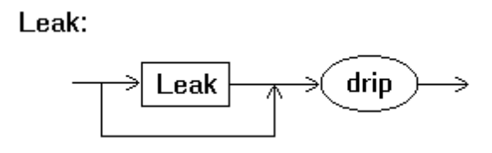

ANSWER:
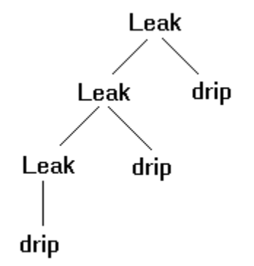

10. Show that the grammar below is ambiguous by drawing two distinct parse trees for the string “drip drip drip.”
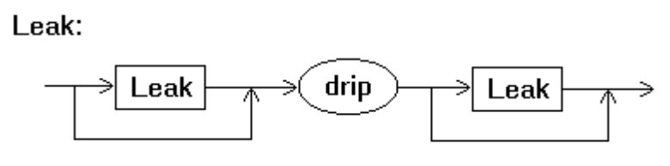

ANSWER: Possible answers include:

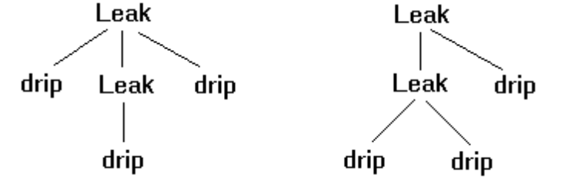

11. In the context of the object-oriented paradigm, what is a constructor?

ANSWER: A constructor is a special “method” that is executed when an object is first constructed, normally for the purpose of performing initialization activities.

12. Briefly describe the task of each of the following.

A. Lexical analyzer

B. Parser

C. Code Generator

ANSWER: A. Groups symbols together to form tokens
B. Ascertains the grammatical role of program’s components
C. Constructs object program

13. Explain why key words in a programming language are often reserved words.

ANSWER: Key words are used to help the parser identify grammatical structures in a program. Thus, using these words are used for other purposes could confuse the parser.

